Parish Councillors are duly summoned to attend a Briercliffe with Extwistle Annual Parish Council meeting to be held Thursday 12th June 2025 at 5pm at the Community Centre, Jubilee Street

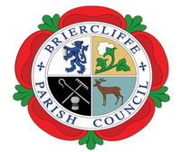

Members of the public are invited to attend.

BRIERCLIFFE WITH EXTWISTLE PARISH COUNCIL

PARISH COUNCIL MEETING

Thursday 12th June 2025 5pm

Welcome

1. Announcements

2. Apologies for absence and reasons given

3. Declarations of Disclosable Pecuniary Interests

4 Parish Council members.

5.Finance

5.1 Approve the dates for the Public Rights for audit.

5.2 Approve the AGAR

6 Dates of meetings in 2025

* July 10th 2025
* Aug 14th   2025
* Sept 11th 2025
* Oct 2nd 2025
* Nov 6th 2025
* Dec 4th  2025
* Jan 8th  2026
* Feb 5th 2026
* Mar 5th 2026
* Apr 2th 2026
* May 14th  2026 (and Annual meeting; first meeting after elections)